REST API(Representational State Transfer)

The REST API allows you to interact with parse from anything that can send an HTTP request. All API's access is over HTTPS with the same HTTPS verbs (GET, POST, PUT, DELETE, etc) that web browsers use to retrieve web pages and to send data to remote servers.

The fallowing HTTP methods are used to implement a RESTful API:
GET Method :
Retrieving Objects.
POST Method :
Creating Objects.
PUT Method :
Updating Objects.
DELETE Method :
Deleting Objects.
Traffic Manager

Microsoft Azure Traffic Manager allows you to control the distribution of user traffic to your specified endpoints, which can include Azure services, websites, and other endpoints. Traffic Manager works by applying an intelligent policy engine to Domain Name System(DNS) queries for the domain names of your Internet resources. Your Azure cloud services or websites can be running in different data centers across the world.

How The traffic manager works.
When you configure a Traffic Manager profile, the settings that you specify provide Traffic Manager with the information needed to determine which endpoint should service the request based on a DNS query. No actual endpoint traffic routes through Traffic Manager.

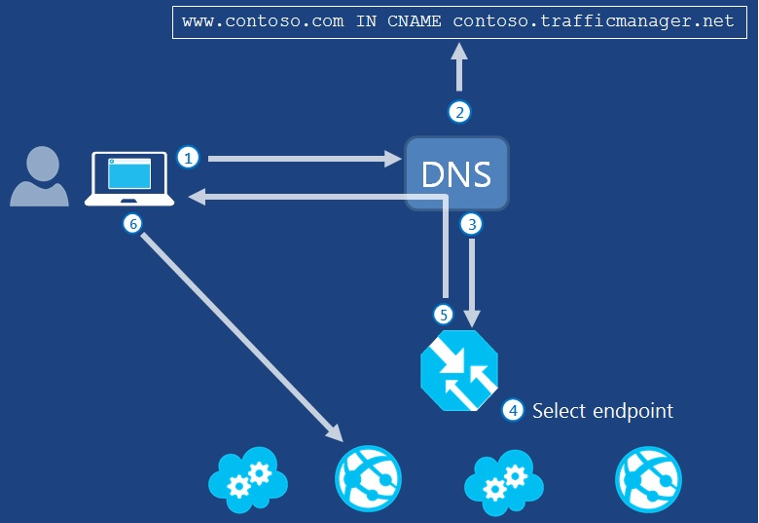

User traffic to company domain name: The client requests information using the company domain name. The goal is to resolve a DNS name to an IP address. Company domains must be reserved through normal Internet domain name registrations that are maintained outside of Traffic Manager. In Figure 1, the example company domain is www.contoso.com.
- Company domain name to Traffic Manager domain name: The DNS resource record for the company domain points to a Traffic Manager domain name maintained in Azure Traffic Manager. This is achieved by using a CNAME resource record that maps the company domain name to the Traffic Manager domain name. In the example, the Traffic Manager domain name is contoso.trafficmanager.net.
- Traffic Manager domain name and profile: The Traffic Manager domain name is part of the Traffic Manager profile. The user's DNS server sends a new DNS query for the Traffic Manager domain name (in our example, contoso.trafficmanager.net), which is received by the Traffic Manager DNS name servers.
- Traffic Manager profile rules processed: Traffic Manager uses the specified traffic routing method and monitoring status to determine which Azure or other endpoint should service the request.
- Endpoint domain name sent to user: Traffic Manager returns a CNAME record that maps the Traffic Manager domain name to the domain name of the endpoint. The user's DNS server resolves the endpoint domain name to its IP address and sends it to the user.
- User calls the endpoint: The user calls the returned endpoint directly using its IP address.

Azure Traffic manager REST API

The fallowing Operations for Azure Traffic Manager
- Create or Update the Traffic Manager Profile.
- Delete a Traffic Manager Profile.
- Get Traffic Manager Profile.
- List Traffic Manager Profile.
- Create or Update the Traffic Manager endpoints.
- Get a Traffic Manager endpoints.
- Delete a Traffic Manager endpoints.

1. Create or Update the Traffic Manager Profile.
Create or update a Traffic Manager profile within a resource group.
Method – PUT
Request URI
“https://management.azure.com/subscriptions/{subscription-id}/resourceGroups/{resource-group-name}/providers/Microsoft.Network/trafficManagerProfiles/{profile-name}?api-version={api-version} “
Parameters :-
{
"location": "global",
"tags": {},
"properties": {
"profileStatus": "Enabled",
"trafficRoutingMethod": "Performance",
"dnsConfig": {
"relativeName": "myapp",
"ttl": 30
},
"monitorConfig": {
"protocol": "http",
"port": 80,
"path": "/monitorpage.aspx"
},
"endpoints": [
{
"name": "{endpoint-name}",
"type": "Microsoft.Network/trafficManagerProfiles/azureEndpoints",
"properties": {
"targetResourceId": "{resource ID of target resource in Azure}",
"endpointStatus": "Enabled",
"weight": 10,
"priority": 3
}
},
}
]
}
}

Response :-
Status code: 200 or 201 depending on whether the resource is updated or created.
- Delete a Traffic Manager Profile
Delete an existing Traffic Manager Profile.
Method : - DELETE

Request URI :-
“https://management.azure.com/subscriptions/{subscription-id}/resourceGroups/{resource-group-name}/providers/Microsoft.Network/trafficManagerProfiles/{profile-name}?api-version={api-version} ”
Response :-
Status code: 200 or 204 depending on whether the Traffic Manager profile was deleted or was not found.

- Create or update Traffic Manager endpoint.
Each profile contains a list of endpoints. These endpoints are child resource of the profile, each with their own unique ARM resource id. Thus endpoints can be managed in two ways: both by modifying the endpoints list when updating a profile, or by modifying the endpoint resource directly.
Method :- PUT
Request URI
“https://management.azure.com/subscriptions/{subscription-id}/resourceGroups/{resource-group-name}/providers/Microsoft.Network/trafficManagerProfiles/{profile-name}/{endpoint-type}/{endpoint-name}?api-version={api-version} ”
Parameters :-
{
"name": "{endpoint-name}",
"type": "Microsoft.Network/trafficManagerProfiles/azureEndpoints",
"properties": {
"targetResourceId": "{resource ID of target resource in Azure}",
"endpointStatus": "Enabled",
"weight": 10,
"priority": 3
}
Response :-
Status code: 200 or 201 depending on whether the endpoint resource is updated or created.
- Delete the Manager Traffic endpoints
Each profile contains a list of endpoints. These endpoints are child resource of the profile, each with their own unique ARM resource id. Thus an endpoint can be deleted in two ways: both by updating the endpoints list in the profile, or by deleting the endpoint resource directly.

Method :- DELETE
Request URI :-
“https://management.azure.com/subscriptions/{subscription-id}/resourceGroups/{resource-group-name}/providers/Microsoft.Network/trafficManagerProfiles/{profile-name}/{endpoint-type}/{endpoint-name}?api-version={api-version} ”
Response :-
Status code: 200 or 204 depending on whether the Traffic Manager endpoint was deleted or was not found

